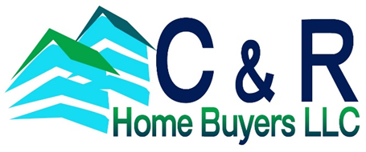
This home will be gorgeous! 4 Bedroom 3 Full Baths and fully renovated with all the bells and whistles You will Love the quality of workmanship, natural light and beautiful finishing touches. You will immediately fall in love with the open floor plan and warm gleaming hardwood floors. Abundant recessed lighting and french doors leading to the large back yard. Open concept gourmet kitchen with custom wood easy close cabinets, a large peninsula, granite counters, recessed lighting, brand new Whirlpool stainless steel appliances. The impeccable color coordination will leave you totally satisfied! The kitchen will be great for entertaining with the addition of a generous sized dining room and family room with french doors. Everything is new!!! New roof, siding, double hung windows, new HVAC / Central Air system, appliances, 200 amp electric, plumbing, kitchen cabinets, counters, lighting, carpet, baths, If you need room, you'll find it here!! Home Sweet Home!!! You will not be disappointed!

FOR SALE
43 NUTMEG LANE, LEVITTOWN, PA 19054
4 Bedrooms, 3 Full Baths, 2350 sq ft

Check out our website to see additional homes for sale!
215-919-0167 or visit our website
www.crhomebuyers.com

